## Exercise 1.1.4: Say Hello!

When you learn a new programming language, it is tradition that the first program that you write is a “Hello World!” program.

Create a “Hello, Worldwide Web!” HTML web page!

Use a <h1> tag to create the heading “Hello, Worldwide Web!”

Like this:

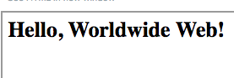

HINT:

The <h1> tag can be found in the green “Formatting” section in the block tool box.